Learning Journal Unit 7

Godfrey Ouma
University of the People
MATH 1211: Calculus
Rakesh Das
January 4, 2024

Learning Journal Unit 7
The question: Evaluate $\lim_{x→0^{+}}\left(\frac{1}{x}-\frac{1}{sinx}\right)$
- Describe why you find it interesting.
I find the question interesting because when substituting x with 0 directly into the expression $\frac{1}{x}-\frac{1}{sinx}$, we get $∞-∞$, which is another type of indeterminate form. Since $∞-∞$ has no meaning on its own and we must do more analysis to determine the value of the limit.
- either solve it or find a solution online.
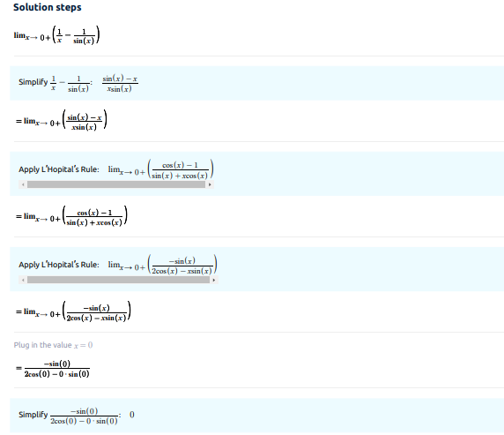
- work through it using your own understanding to critique that solution and improve it.
The solution to evaluating $\lim_{x→0^{+}}\left(\frac{1}{x}-\frac{1}{sinx}\right)$ in part (b) above was obtained from an online math tool called Symbolab, which showed the step-by-step calculations from the beginning until the final answer, which is zero. Going through all the solution steps, the fractional parts of the two expressions were added to get a single fraction, which was correctly done to get $\frac{sinx-x}{xsinx}$. In the second step, applying the L'Hopital's Rule for the first time by taking derivative of the numerator and denominator leads to $\frac{cosx-1}{sinx+xcosx}$. The derivative of both numerator and denominator were correct, with the derivative of the denominator determine by applying product rule. It could be that at this point, direct substitution of the value of x with 0 to the expression $\frac{cosx-1}{sinx+xcosx}$ would result to indeterminate form type $\frac{0}{0}$, hence the need to apply the L'Hopital's Rule for the second time. The second derivative of both numerator and denominator were also perfectly done leading to $\frac{-sinx}{2cosx-xsinx}$. At this point, direct substitution of x with 0 in the expression result in 0, which is the solution to $\lim_{x→0^{+}}\left(\frac{1}{x}-\frac{1}{sinx}\right)$.
However, despite the correct calculations obtained from the online calculator, a few explanations are missing to help a person understand the limit of the expression was found as $x→0^{+}$. To improve on the solution above, I would mention the need to first check if direct substitution of x with 0 into the expression would lead to indeterminate form before deciding to apply the L'Hopital's Rule. By doing so, it would make it easier to understand when is the L'Hopital's Rule applicable and which type of indeterminate form existed when solving the expression. For example, in the question above, we realize that there was indeterminate form of two types. First, $∞-∞$ at the beginning (which led to application of L'Hopital's Rule for the first time), and second, $\frac{0}{0}$ (which led to application of L'Hopital's Rule for the second time). By doing so, it makes it easier to understand every step of the calculations done. Nonetheless, it is unclear from the calculation above why the L'Hopital's Rule was applied and which type of indeterminate form was obtained after substituting x with 0 directly in the expression.

References
Herman, E. & Strang, G. (2020). Calculus volume 1. OpenStacks. Rice University.
Limit As X Approaches 0^+of 1/x-1/(sinx). (2024, January 1). Symbolab Math Calculator - Step by Step Calculator. https://www.symbolab.com/solver/limit-calculator/%5Clim_%7Bx%5Cto0%5E%7B%2B%7D%20%7D%5Cleft(%5Cfrac%7B1%7D%7Bx%7D-%5Cfrac%7B1%7D%7Bsinx%7D%5Cright)?or=input

